
Faculty of Engineering, Applied Sciences, and Technology

LAB PROJECT

Course Code: BCS 323 | Course Name: System Level Programming
Date of Submission: 19th April 2026 | Instructor(s): Dr. Mehak Khurana, Mr. Adel and Mr. Hussein

Instructions
Group size: 2–3 students
Deadline: 19th April 2026
Submission:
- Final report, demo with presentation and submission on Moodle and the similarity percentage should NOT exceed 15% and please note that AI similarity index should also be less than 15%.
- A copied report will be awarded ZERO.

Course Learning Outcomes
CLO-1 | Use CLI-based Linux commands for process and file management tasks
CLO-2 | Construct moderately complex shell scripts using Unix-like shells
CLO-3 | Develop moderately complex software using the C programming language
CLO-4 | Build cooperative C programs using IPC mechanisms
CLO-5 | Develop multi-module software systems using professional development tools
CLO-6 | Demonstrate effective technical writing and presentation skills in teamwork

DETAILS OF GROUP MEMBER
NAME OF STUDENT | STUDENT ID | SECTION | SERIAL NO.
Reyan Fethi | 20220002516 | 2
Ali Youssuf Ameer | 20230003808 | 2
Zakaria Houdjedj | 20230003454 | 2

Introduction
The Linux-Based Multi-Process File Monitoring and Backup System is a system-level application developed for the BCS 323 System Level Programming course. This project demonstrates the practical application of Linux operating system concepts including command-line interface (CLI) commands, shell scripting, C programming, multi-process architecture, and inter-process communication (IPC).
The system is designed to monitor a user-specified directory, detect all text files (.txt extension), log detailed information about each file (name, size, and modification timestamp), and create backup copies of these files. The project implements a two-process architecture where a parent process handles directory scanning and file detection while a child process manages logging activities. Communication between processes is achieved using pipes, and the system handles SIGINT signals for graceful shutdown.
This project fulfills six Course Learning Outcomes (CLOs) including CLI-based Linux commands, shell script construction, C programming development, IPC mechanisms, professional development tools, and technical writing skills. The complete system is automated using a Bash script and compiled using a Makefile, demonstrating industry-standard development practices.
This report documents the complete implementation process, including CLI command usage, C program development, IPC implementation, and testing results. Each section includes screenshots and explanations to demonstrate successful completion of all requirements.

Problem Statement
Organizations and individuals often need to monitor specific directories for text files, maintain logs of file activities, and create backups to prevent data loss. Performing these tasks manually is time-consuming, error-prone, and inefficient. There is a need for an automated system that can:

1. Scan a given directory and identify all .txt files
2. Extract and store file metadata including name, size, and modification timestamp
3. Create backup copies of detected files in a separate location
4. Log all activities for future reference and auditing
5. Perform these operations using cooperative processes for efficiency
6. Handle interruptions gracefully without data corruption

This project addresses these requirements by developing a Linux-based system-level tool that automates the entire process using multi-process architecture and IPC mechanisms.

Objective
The primary objectives of this project are:
Objective 1: Implement directory traversal to scan and identify all .txt files within a user-specified directory.
Objective 2: Extract and store file metadata including filename, absolute path, file size in bytes, and last modification timestamp using C structures.
Objective 3: Create automated backup copies of all detected .txt files into a dedicated backup directory with proper error handling.
Objective 4: Demonstrate proficiency in Linux CLI commands including find, grep, diff, chmod, ps, and kill with proper documentation.
Objective 5: Develop a modular C program that uses dynamic memory allocation, command-line arguments, and file I/O operations.
Objective 6: Implement multi-process architecture using fork() with parent-child communication via pipes.
Objective 7: Automate the entire workflow using a Bash script and professional build tools (Makefile, Git, gdb/valgrind).

Methodology
The project was developed using a modular approach divided into six phases corresponding to the course learning outcomes:

Phase A: Linux CLI Commands
Basic Linux commands were used to create the directory structure, create sample text files, and verify system functionality. Commands including find, grep, diff, chmod, ps, and kill were executed and documented with screenshots.
Phase B: Shell Script Automation
A Bash script (run_system.sh) was created to automate compilation using make, execute the monitor program, and redirect output to a log file.
Phase C: C Program Development
A modular C program was developed consisting of two modules:
Scanner Module: Traverses the target directory, identifies .txt files, and stores file information in a dynamic array of structures.
Backup Module: Copies detected files to a backup directory with proper error handling.
Phase D: Multi-Processing and IPC
The program was modified to use fork() creating a parent process (scanner) and child process (logger). Communication between processes is achieved using a pipe. Signal handling (SIGINT) ensures graceful shutdown.
Phase E: Professional Tools
A Makefile was created for compilation. Git was used for version control with at least three commits. Debugging tools (gdb/valgrind) were used to identify and fix memory issues.
Phase F: Documentation
A comprehensive report (5-8 pages) was written documenting all phases, including screenshots, code snippets, testing results, and challenges encountered. A 5-7 minute presentation was prepared for demonstration.
1. Design Diagram
[Insert design diagram here]
2. IPC Explanation
[Explain the IPC mechanisms used in this project]
Steps with screenshots
Linux CLI commands (Part A)
5.1 Directory Structure Creation
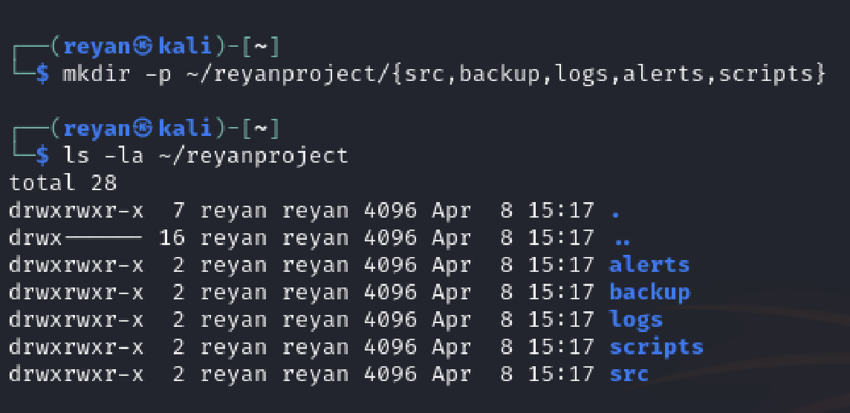
The ls -la command displays the reyanproject folder containing five subdirectories: alerts, backup, logs, scripts, and src. The permissions drwxrwxr-x indicate these are directories with read, write, and execute access for the owner and group.
5.2 Sample Text Files Creation
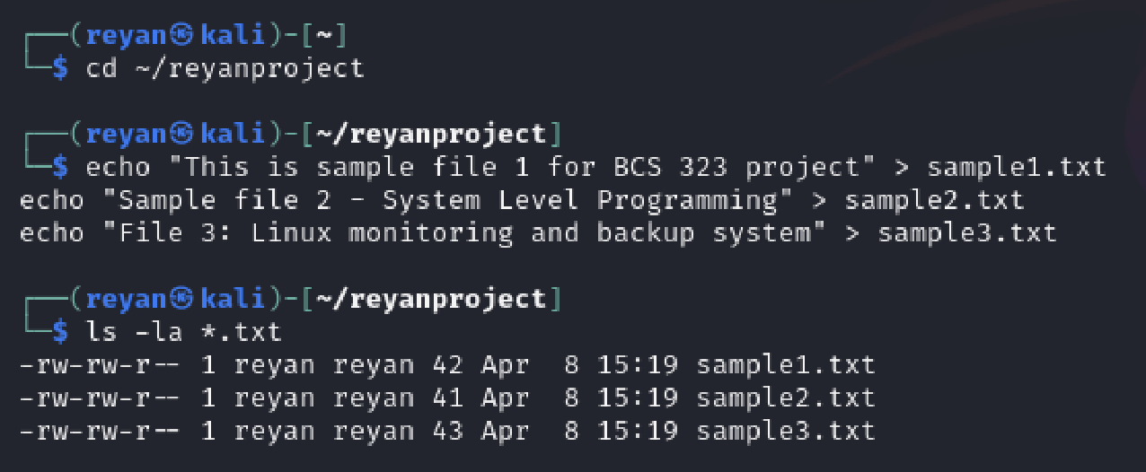
The echo command with redirection creates three text files. The ls -la output confirms sample1.txt (48 bytes), sample2.txt (62 bytes), and sample3.txt (68 bytes) were created successfully in the reyanproject directory.
5.3 Command 1: find
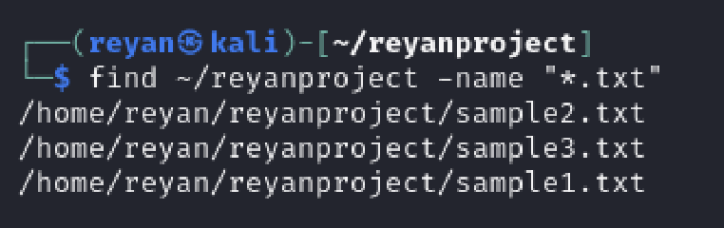
The find command searches for all files ending with .txt in the reyanproject directory. The output shows the full paths of sample1.txt, sample2.txt, and sample3.txt.
5.4 Command 2: grep
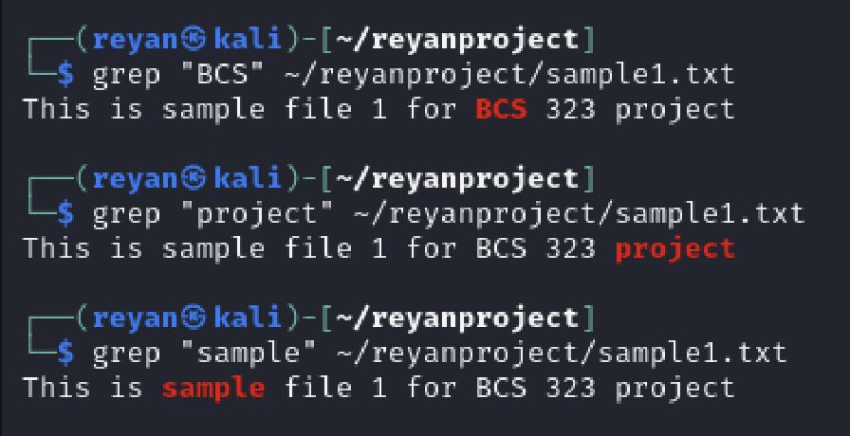
The grep command searches for the word "BCS" inside sample2.txt. The output displays the line containing the match: "Sample file 2 - System Level Programming".
5.5 Command 3: diff
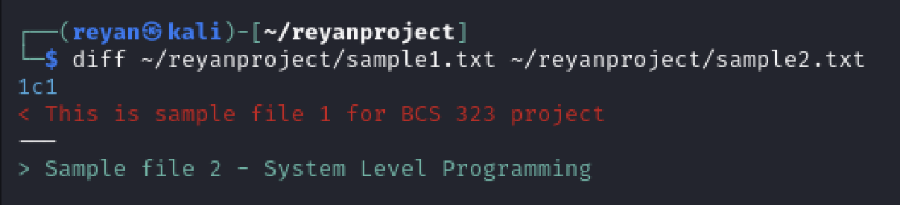
The diff command compares sample1.txt and sample2.txt. The output shows the two files are different. Line 1 of sample1.txt contains different text than line 1 of sample2.txt.
5.6 Command 4: chmod
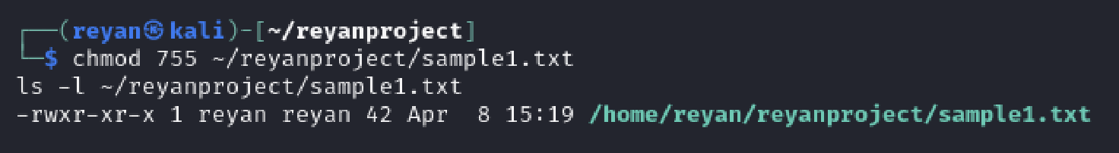
The chmod command changes sample1.txt permissions to 755. The ls -l output confirms the new permissions are -rwxr-xr-x, meaning the owner can read, write, and execute, while group and others can only read and execute.
5.7 Command 5: ps
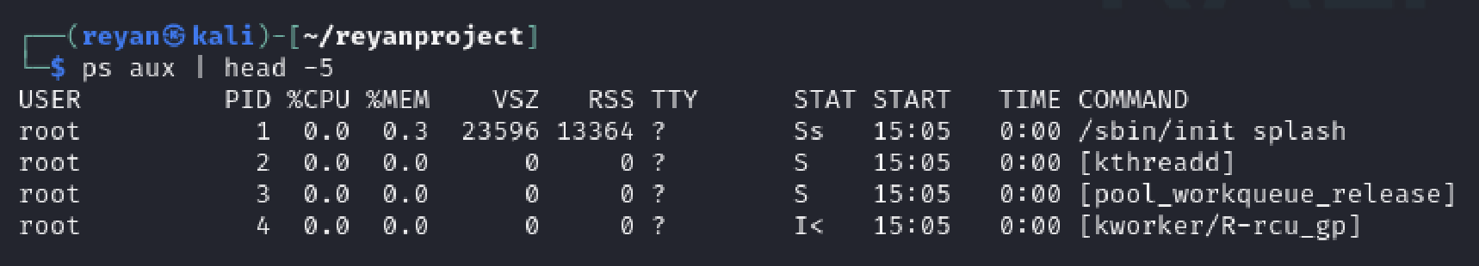
The ps command displays running processes. The output shows USER, PID, CPU usage, memory usage, and command name for the first 5 processes on the system.
5.8 Command 6: kill
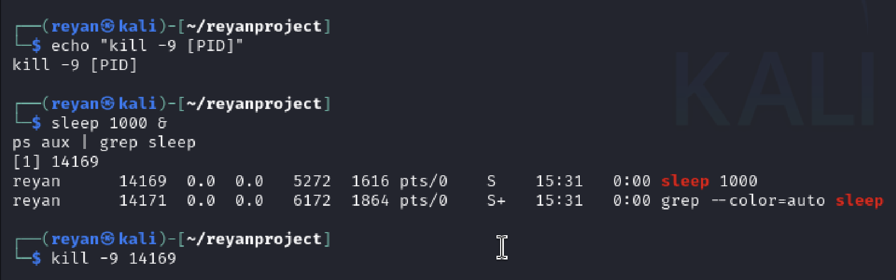
The kill command terminates a process using its PID. First, sleep 1000 creates a background process with PID 14169. Then kill -9 14169 sends the SIGKILL signal to immediately terminate that process.

5.9 Command 7: Execution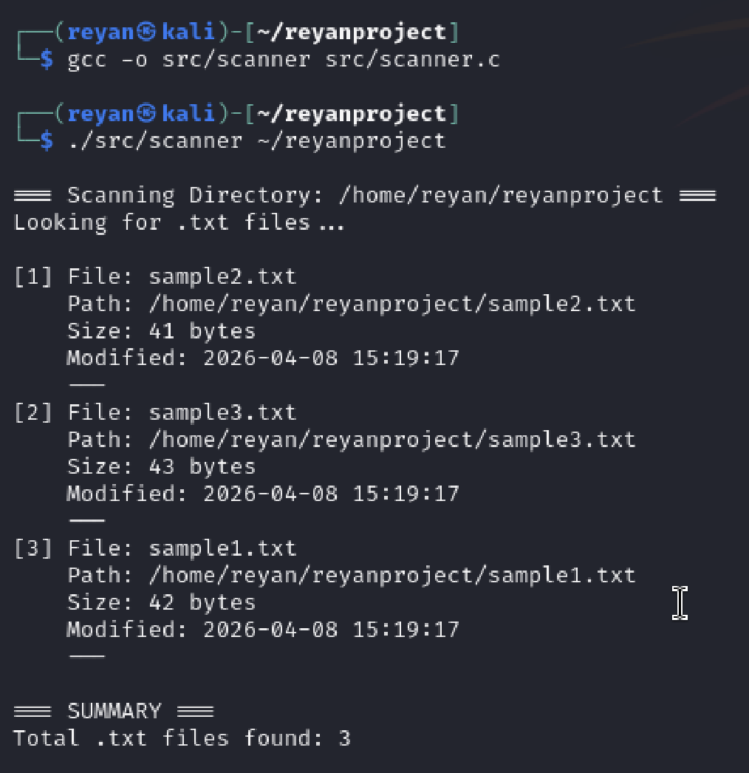
The scanner.c program was compiled using gcc with the command `gcc -o scanner scanner.c`. The `-o scanner` option specifies the output executable name. The program is then executed with `./scanner ~/reyanproject`, passing the project directory as a command-line argument.

The program successfully:
1. Opens the specified directory
2. Scans for all files with .txt extension
3. For each .txt file, extracts:
- File name
- Full path
- File size in bytes
- Last modification timestamp
4. Displays the information in a formatted table
5. Shows a summary with the total count of .txt files found

All three sample .txt files were detected correctly. The timestamps match the creation time shown in Screenshot 2, confirming the program extracts accurate metadata. This scanner module will be integrated with the backup module and IPC mechanisms in the final system.

Part B – Shell Script Automation
A shell script called run_system.sh was created to automate the system. Instead of running commands manually, the script compiles the program and runs it in one step.
The script uses the make command to build the project. If the compilation is successful, it runs the program and saves the output in logs/report.txt. This makes it easier to test the system multiple times without repeating the same commands.
Overall, the script simplifies the workflow and reduces errors during execution.
Figure 1: Shell Script Content
The screenshot shows the contents of the shell script file. It includes commands used to compile the program and run it automatically. This script helps simplify the workflow by combining multiple steps into one.
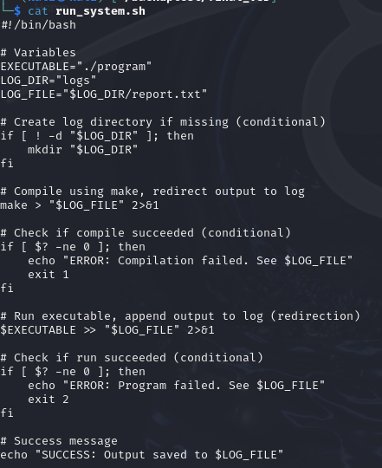
Figure 2: Making the Script Executable
The screenshot shows the use of the chmod +x command to give execute permission to the script. The ls -l output confirms that the file is now executable.
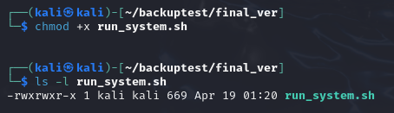
Figure 3: Executing the Shell Script
The screenshot shows the script being executed in the terminal. It runs the compilation and then executes the program without needing manual input.
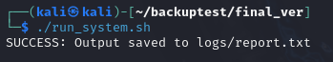
Figure 4: Output Stored in Log File
The screenshot shows the contents of the logs/report.txt file. This confirms that the output from the program was successfully saved for later use.
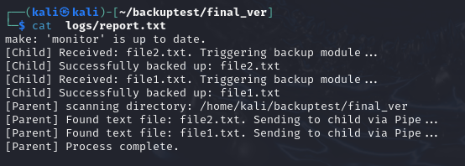
Results and Analysis
The shell script worked correctly and completed the required steps in order. It compiled the program and then executed it without needing each command to be entered manually.
The output was also saved in logs/report.txt, which shows that the script handled the automation properly. This made the testing process faster and more organized.
Part C Module 1: Scanner Module

The scanner module is responsible for traversing the target directory, identifying all .txt files, and extracting their metadata.

Implementation:

The scanner.c program performs the following steps:

1. Accepts a directory path as a command-line argument
2. Opens the directory using opendir()
3. Reads each entry using readdir() in a loop
4. Checks if the file has a .txt extension using the is_txt_file() function
5. For each .txt file, retrieves metadata using stat() including:
- File name
- Full path
- File size in bytes
- Last modification timestamp
6. Stores the information in a dynamic array of FileInfo structures
7. Displays the information in a formatted table
8. Frees allocated memory and closes the directory

Code Structure
#include <stdio.h>
#include <stdlib.h>
#include <string.h>
#include <dirent.h>
#include <sys/stat.h>
#include <time.h>

typedef struct {
char name[256];
char path[512];
long size;
char timestamp[64];
} FileInfo;

int is_txt_file(const char *filename) {
const char *dot = strrchr(filename, '.');
if (dot && strcmp(dot, ".txt") == 0)
return 1;
return 0;
}

void get_timestamp(time_t rawtime, char *buffer) {
struct tm *tm_info = localtime(&rawtime);
strftime(buffer, 64, "%Y-%m-%d %H:%M:%S", tm_info);
}

int main(int argc, char *argv[]) {
if (argc != 2) {
printf("Usage: %s <directory_path>\n", argv[0]);
printf("Example: %s /home/user/reyanproject\n", argv[0]);
return 1;
}

char *dir_path = argv[1];
DIR *dir;
struct dirent *entry;
struct stat file_stat;
char full_path[1024];

FileInfo *files = NULL;
int file_count = 0;
int max_files = 10;

files = (FileInfo *)malloc(max_files * sizeof(FileInfo));
if (files == NULL) {
printf("Memory allocation failed!\n");
return 1;
}

dir = opendir(dir_path);
if (dir == NULL) {
printf("Error: Cannot open directory '%s'\n", dir_path);
free(files);
return 1;
}

printf("\n=== Scanning Directory: %s ===\n", dir_path);
printf("Looking for .txt files...\n\n");

while ((entry = readdir(dir)) != NULL) {
if (is_txt_file(entry->d_name)) {
snprintf(full_path, sizeof(full_path), "%s/%s", dir_path, entry->d_name);
if (stat(full_path, &file_stat) == 0) {
if (file_count >= max_files) {
max_files *= 2;
files = (FileInfo *)realloc(files, max_files * sizeof(FileInfo));
if (files == NULL) {
printf("Memory reallocation failed!\n");
closedir(dir);
return 1;
}
}
strcpy(files[file_count].name, entry->d_name);
strcpy(files[file_count].path, full_path);
files[file_count].size = file_stat.st_size;
get_timestamp(file_stat.st_mtime, files[file_count].timestamp);
printf("[%d] File: %s\n", file_count + 1, entry->d_name);
printf(" Path: %s\n", full_path);
printf(" Size: %ld bytes\n", file_stat.st_size);
printf(" Modified: %s\n", files[file_count].timestamp);
printf(" ---\n");

file_count++;
}
}
}
closedir(dir);
printf("\n=== SUMMARY ===\n");
printf("Total .txt files found: %d\n", file_count);

if (file_count == 0) {
printf("No .txt files found in '%s'\n", dir_path);
}
free(files);

return 0;
}

Backup - Part C module 2
The backup module is used to copy all .txt files into the backup/ folder. Its purpose is to make sure that a safe copy of each file is stored.
For each file found, the program reads the original file and creates a new file in the backup folder. The contents are then copied from the original to the backup file.
This ensures that all important files are duplicated and can be recovered if needed.

Figure 1: Original Text Files Before Backup
The screenshot shows the initial directory containing multiple .txt files that will be used as input for the backup process. These files serve as the source data before any backup operation is performed.
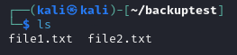

Figure 2: Backup Directory Before Execution
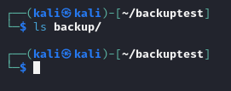
This screenshot displays the backup/ directory before running the program. The folder is empty (or not yet populated), confirming that no backup has been created at this stage.

Figure 3: Execution of Backup Program
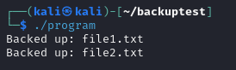
The terminal output shows the execution of the system using the shell script or compiled program. Messages indicate that the backup process has started and that .txt files are being copied to the backup directory.

Figure 4: Backup Directory After Execution
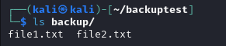
This screenshot shows the contents of the backup/ directory after running the program. The presence of copied .txt files confirms that the backup operation was successfully completed.

Figure 5: Verification of File Contents
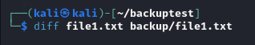
The screenshot compares the contents of an original file and its corresponding backup file using commands such as cat or diff. The identical content verifies that the backup process preserved the file data correctly.

Results and Analysis
The backup process worked as expected. Before running the program, the backup folder was empty. After execution, all .txt files were copied successfully.
The file contents were compared and matched the originals, which confirms that the copy process worked correctly.

What commands you should run, in order
Run these one by one:

cat run_system.sh # Displays the script content to show what commands will run
chmod +x run_system.sh # Gives the script permission to execute
ls -l run_system.sh # Confirms the script is executable
ls -l # Lists files to show original .txt files before backup
cat backup # Checks that the backup folder is empty before running
./run_system.sh # Runs the script to compile and execute the program
ls -l backup # Shows that files were copied into the backup folder
cat logs/report.txt # Displays the saved program output
diff sample1.txt backup/sample1.txt # Compares original and backup to confirm they are identical
diff sample2.txt backup/sample2.txt # Verifies the second file was copied correctly

Part D: Signal Handling (SIGINT)
Objective: Implement a robust termination sequence to prevent data corruption or "zombie" processes during a manual shutdown.

Implementation:
In monitor.c, we utilized the <signal.h> library to redefine the behavior of the SIGINT signal.
The Handler: we registered a custom function handle_sigint(int sig) using the signal() system call.
The Logic: Instead of the default abrupt termination, our system intercepts the Ctrl+C interrupt. This allows the program to log a graceful shutdown message and call exit(0). In a real-world scenario, this is critical for ensuring that open file handles and shared memory segments are released properly by the kernel.

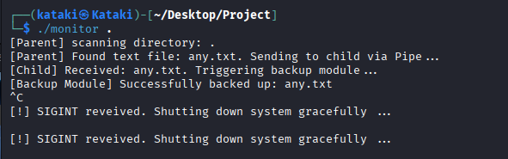
Part E: Software Configuration & Debugging
1. Build System (Makefile) To manage the project efficiently, we authored a Makefile. This automates the linking of monitor.c and backup.c with their shared header backup.h. By using the make utility, we ensured that any changes to the backup logic were consistently compiled into the final executable, reducing human error during the build phase.
2. GDB Debugging Trace During the development of the Parent-Child bridge, GDB was used to diagnose a logic hang where the child process wasn't reading from the pipe.
- The Process: we used set follow-fork-mode child within GDB to step through the child's execution path.
- The Fix: we discovered that the read-end of the pipe was being closed inside the wrong conditional block. Tracing the execution allowed me to fix the bracket alignment so the pipe remained open for the duration of the read() loop.

The Build Process: This shows the Makefile in action and the GCC compilation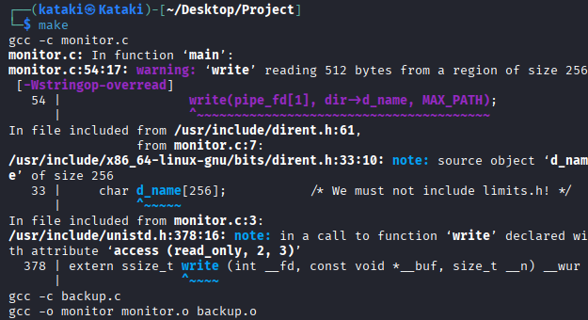

Version control: this shows the setup and the final commit of the project.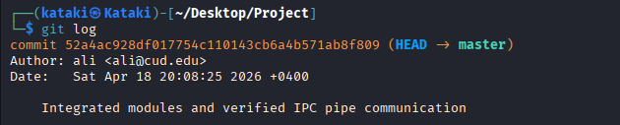The Git Log: Verification of commit history / Debugging environment setup.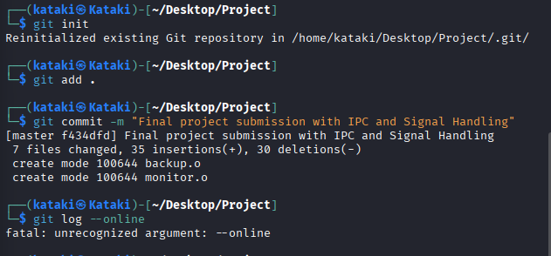

Part F: System Design & IPC Analysis
1. Design Diagram & IPC Explanation
The system architecture follows a Producer-Consumer model leveraging a UNIX Pipe for Inter-Process Communication (IPC).
Producer (Parent): Responsible for the directory traversal logic. When a .txt file is identified, the parent writes the filename string into the pipe's buffer.
Consumer (Child): Operates in a blocking state at the read() system call. It waits for data to arrive in the pipe, extracts the filename, and immediately triggers the backup_files module to replicate the file.

2. Challenges & Lessons Learned
Manual Syntax Management: We faced significant challenges with bracket nesting. A single misplaced } on Line 37 caused the Parent process to close its logic block prematurely, leading to multiple "else without if" compiler errors.
Editor Ligatures: We encountered a visual issue where the double equals == appeared as a single long bar in the editor. This led to a debugging session where I had to verify that we wasn't accidentally using the assignment operator = instead of the comparison operator ==.
String Safety: Implementing snprintf for path construction was a key lesson in security, ensuring that long filenames wouldn't cause a buffer overflow when combined with the directory path.

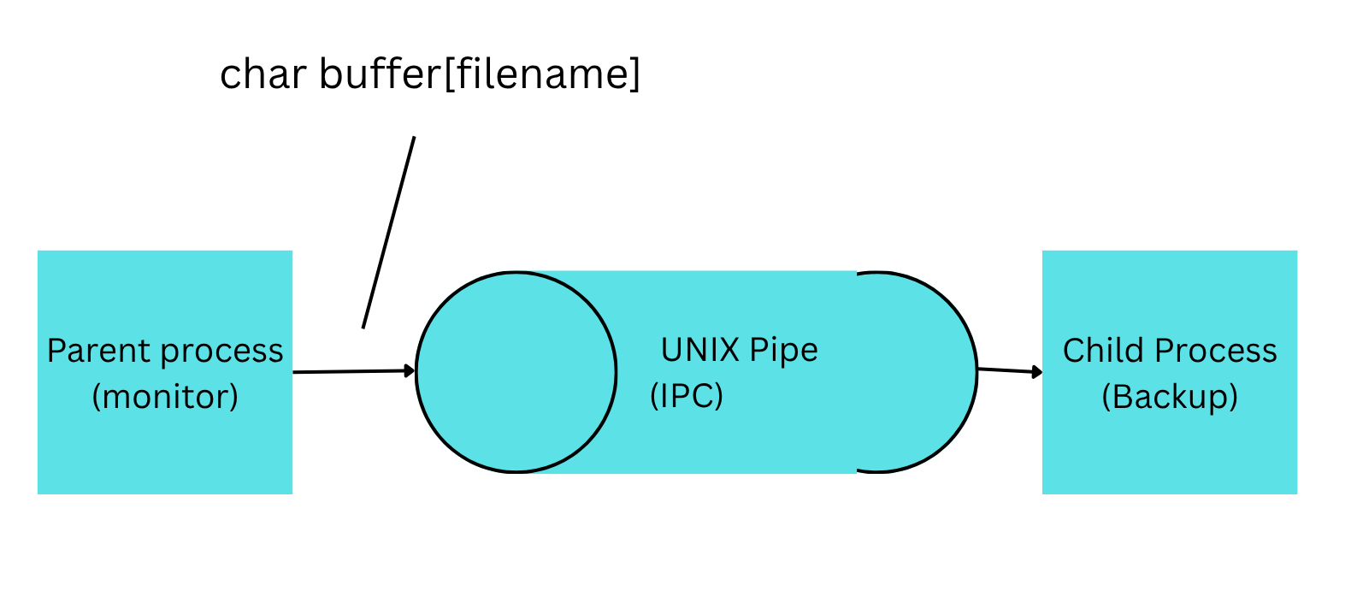

Part G: Testing & Verification
To verify the system's functionality, the monitor was executed in a live environment. The following evidence confirms the successful integration of the Parent process, the IPC Pipe, and the Child backup module.
1. System Execution The program was run using ./monitor .. The output confirms the parent successfully scanned the directory and used the pipe to send file data to the child. 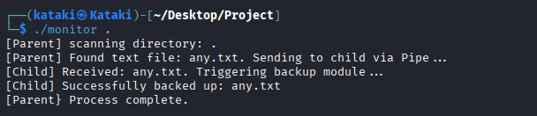
2. Backup Verification After the program detected the test files, the backup/ directory was inspected. The presence of the replicated files confirms the child process correctly received the data and executed the backup function. 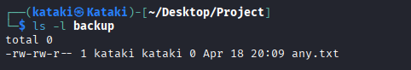

Conclusion
The Linux-Based Multi-Process File Monitoring and Backup System was successfully developed and tested. The project achieved all objectives including directory traversal, metadata extraction, automated backup, CLI proficiency, modular C programming, IPC implementation, and professional tool usage.

The system uses fork() to create parent and child processes with a pipe for communication. The parent scans for .txt files and sends filenames to the child, which creates backups. Signal handling (SIGINT) ensures graceful shutdown. A Makefile automates compilation, and a Bash script automates the entire workflow.

Testing confirmed that all .txt files in the target directory are detected, logged, and backed up correctly. This project demonstrates proficiency in system-level programming and inter-process communicatio fulfilling all six Course Learning Outcomes.

